**Exercise - Use the recorder to automate web applications**

To become familiar with automating web tasks using the recorder, follow the presented instructions to develop a web-based flow. The flow will convert a set amount of USA dollars to euros using the MSN currency converter tool.

To record the flow:

1. Create a new desktop flow and select **Recorder** in the flow designer.
2. When the recorder dialog is launched, select the dots icon of the right side of it and choose the browser you want to use for the automation.

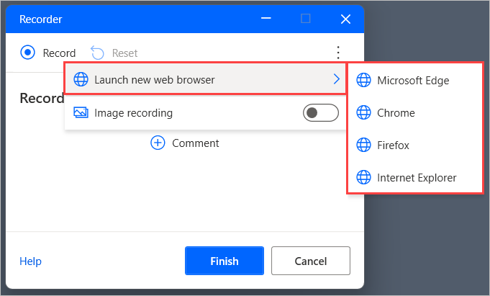

1. After selecting the browser, a browser window will open automatically. Use this window to navigate to the [MSN currency converter page](https://www.msn.com/en-us/money/tools/currencyconverter).

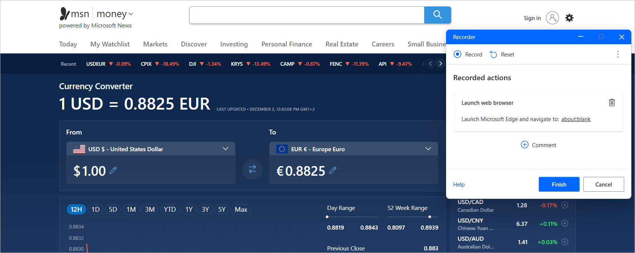

1. Start recording and set the drop-down menus of the converter to **United States Dollar** and **Euro**, respectively.

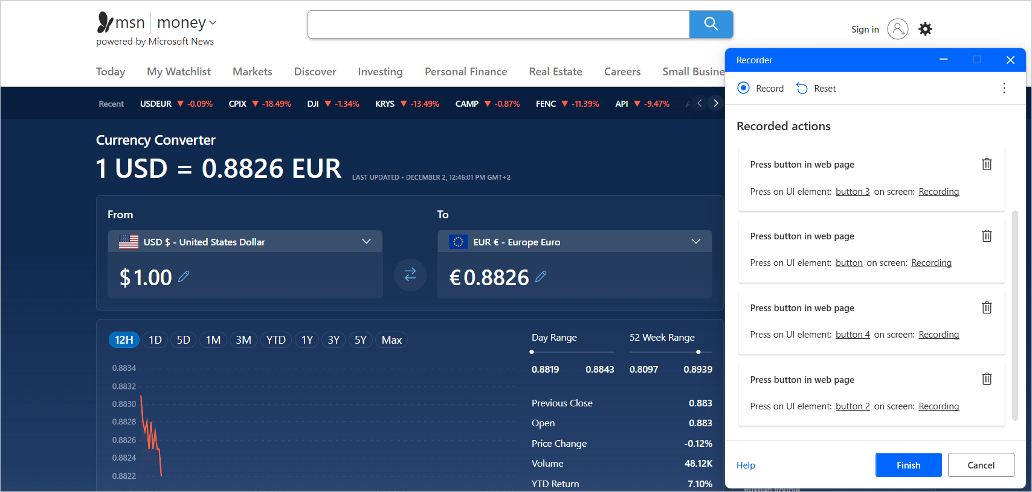

1. Populate the amount of USA dollars to convert in the appropriate field of the page.

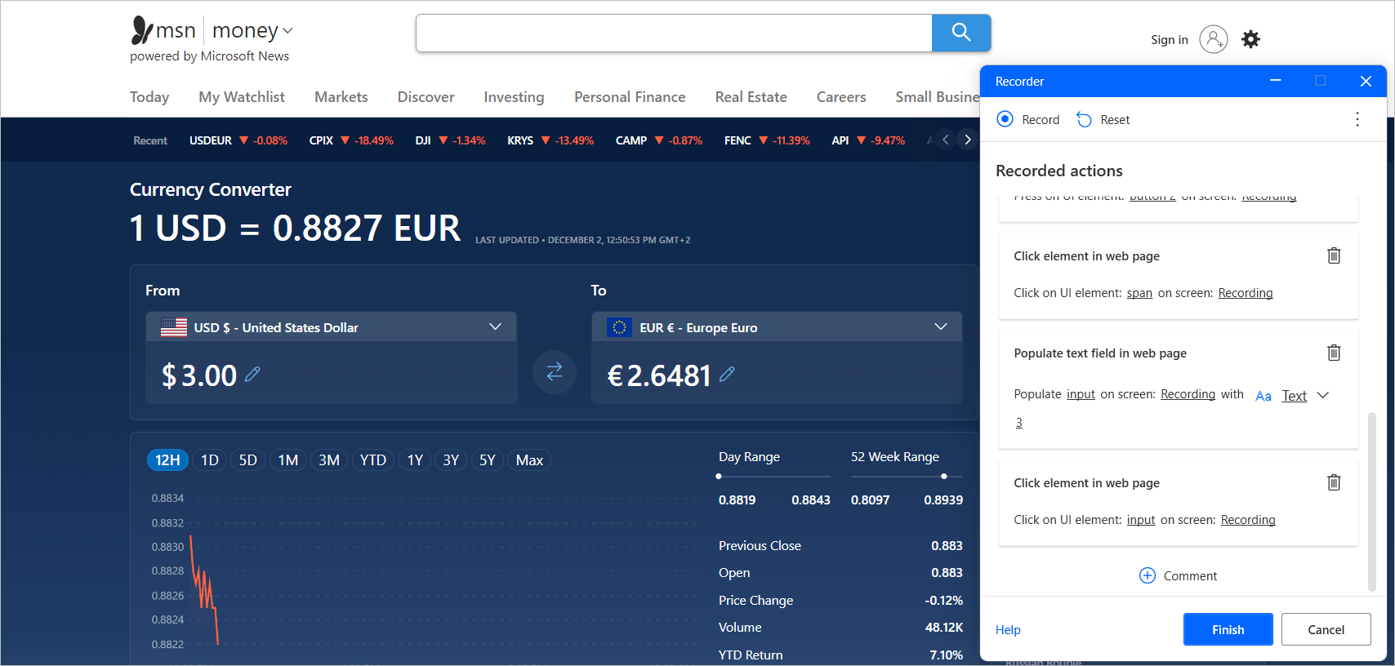

1. Select the field with the converted euros, right-click on it, and extract its value.

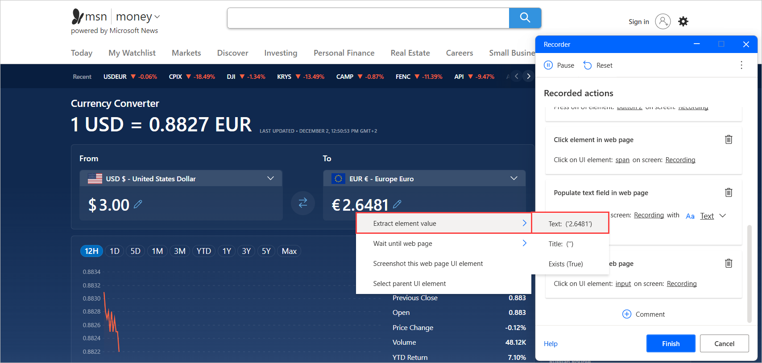

1. Finally, press **Finish** to add all the automatically generated actions to the flow. These actions are no different from any others: they can be moved, edited, or deleted.

